Nepal College of Information Technology
Balkumari, Lalitpur
Assessment-Fall 2009

Program: IT Time: 3 hrs
Semester: Fall FM: 100
Subject: Electronic Circuits I PM: 50
Attempt ALL the questions. Figures at the margin indicate their full marks.

1 (a) Draw two stage R-C coupled BJT amplifier and briefly explain the effect of coupling
Capacitors on its gain? (8)
(b) For the circuit below, find Lower cut off frequency?
Assume β = 100, ro = 50k ohm, re=20 ohm. (8)
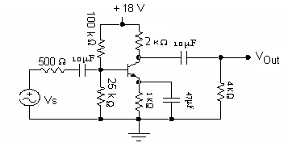

2 (a) Draw Transformer Coupled Load Class B Push pull power amplifier and explain its Operation? (8)

(b) An amplifier has an open loop gain of 35 and feedback ratio of 0.2. If the open loop gain changes by 30% due to temperature, find out the percentage changes in closed loop gain? (5)

3 (a) State Barkhausen criterion for oscillation. Explain Wien-bridge oscillator with circuit Diagram. Derive the expression for the frequency of oscillator? (8)
(b) A Colpitt Oscillator is designed with C₂ =100 pF and C₁ = 7500 pF. The inductance is
Variable. Determine the range of inductance values if the frequency of Oscillation is to vary between 950 KHz to 1050 KHz. (8)

4 (a) what are the main characteristics of an ideal operational amplifier? Draw an adder and subtracter circuit derive its output expression. (8)

(b) Draw block diagram of operational amplifier. Design operational amplifier circuits to produce the following output. V_{o} = 5V₁ – 0.5V₂. (7)

5 (a) Explain the working principle of flash A/D converter. Draw necessary circuit diagram and truth table (8)

(b) Draw R-2R ladder network and explain its operation (8)

6 (a) Discuss various types of filters used in Regulated power supply. (6)

(b) In series regulator circuit overlaid; V_{z} = 7.5v, V_{BE} = 0.7v and β_{dc}=100. Find load voltage, the base current, the Zener current, transistor power dissipation and Zener power dissipation. (7)
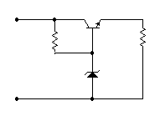

+
–
390Ω
6.8Ω
+
V_{z}
–
15V

7 Write shorts notes on (5*2=10)
i) Ripple factor of Full Wave Rectifier
ii) Switched Mode Voltage regulator
iii) Impedance matching

